](https://spicyricetea.github.io/SunnySideOfTheMoon/splash.html)

**Sunny Side of the Moon**

https://spicyricetea.github.io/SunnySideOfTheMoon/splash.html

John Abbott’s College – Continuing Education

**Course:** Web Design

**Teacher:** Khattar Dao

# Team members

* Ali Nehme
* Edgar Townsend
* Dmitry Kizyakov
* Matthew Rao
* Mitchel Fridman
* Rami Chaouki

# Objectives

Create a website for moon tourism. Our mission is to provide a foundation for a future where tourism on the moon is affordable in the long term. The website also provides an overview of ideas that we believe mega corporations and investors should support after booming space tourism becomes established and profitable. Overall, we are looking ahead to a technological aspect of the human future.

The website was designed as a realistic website that would deliver the message more attractively than pure informational and dull design.

# Audience

* Mega companies
* Investors
* Wealthy people
* Adults interested in space, tourism, and the future.

# Resources

* NASA
* Canadian Space agency
* SpaceX, Virgin Galactic, and Blue Origin websites

# Content, Design and Flowchart

**Figure1: Site map.**

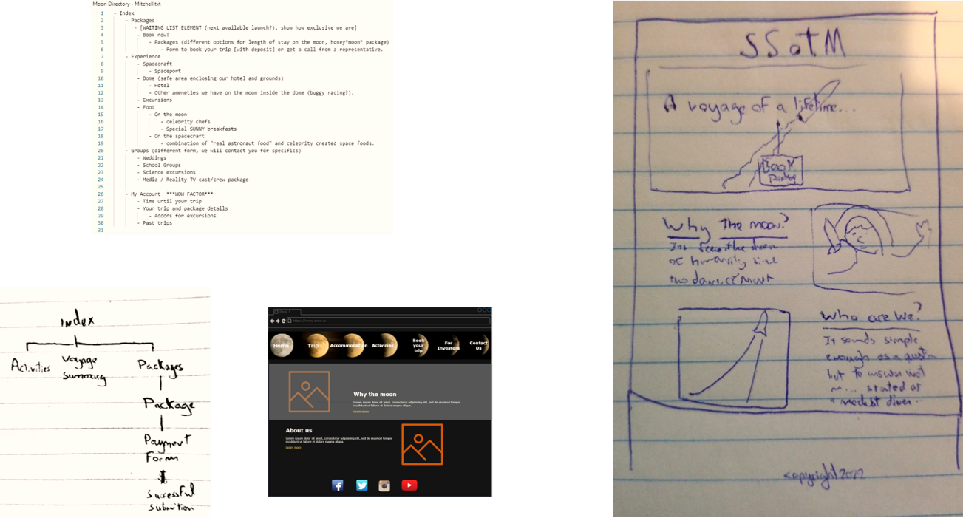

**Figure 2: Some sketches we created for the layout and content design during the brainstorming session.**

**Figure 3: Final Website layout.**

# Work approach

* We used Github for version control and teamwork management.
* We followed Agile practice to work as a team.
* Each member oversaw the creation of one or two web pages and their layout.
* One person was responsible for designing the header and the footer.
* One person was the scrum master, assigning tasks to each member on each sprint.

# Similar websites:

* <https://www.spacex.com/>
* <https://www.virgingalactic.com/>